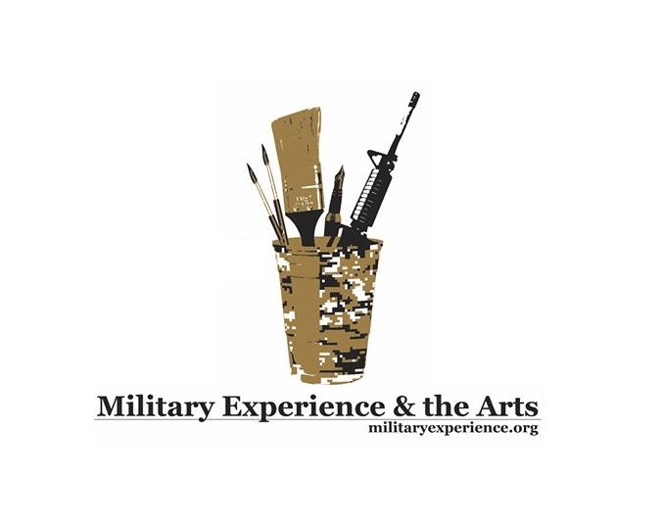

NEWS RELEASE
Media contact: Robin Brooks
Public Affairs
(760) 408-3762

Decorated Army Veteran to Read Combat Poetry
At The Bakery Emporium in Lawton

LAWTON, OK (April 30, 2015) – There is nothing quite like the authentic musings of a poet who has experienced the ravages of war. Local Cameron University professor and Purple Heart recipient, Jason Poudrier, is that unfathomable voice only veterans of combat can truly imagine. Poudrier, the volunteer director of events for a national non-profit organization called Military Experience & the Arts, plans to describe his combat experiences through original verse, Tuesday, May 5 at 6:00 p.m. at The Bakery Emporium located at 1320 NW Homestead Dr Ste A (at the corner of Cache and Homestead Drive). Poudrier, an Army veteran whose tour of duty took place in Iraq, is the author of "Red Fields” and “In the Rubble at Our Feet.” “Veterans such as myself,” said Poudrier, “learn how to better express our personal narratives through the study of the work of other veteran-writers,” he said. The Bakery Emporium’s open-mike night, according to Poudrier, is the perfect opportunity for local veterans, and others, with an interest in expressing themselves via the written word, to commiserate and learn from one another. In addition to the reading, which includes excerpts from both books and selections of fiction, Poudrier will conduct a workshop for attendees beginning at 8 p.m. that involves visual poetry techniques created to assist writers in developing the powerful mental imagery necessary to produce memorable, impactful poems. A monetary donation of $15 for the workshop is highly encouraged and directly benefits the upcoming Military Experience & the Arts National Symposium that opens on the campus of Cameron University from Thursday, May 14 through Sunday, May 17.
- More -
The symposium, an educational event geared toward military veterans and families throughout the State of Oklahoma, as well as the general public seeking a better understanding of how veterans cope within the military environment, is a golden opportunity to allow artistic inclinations to blossom through more than 70 thought-provoking workshops. Topics related to writing, poetry, filmmaking, music, papermaking, performance art and stress reduction are among the symposium offerings. Veterans from Oklahoma, and surrounding states, are invited to register for the symposium – which includes support with lodging, meals, transportation, post-traumatic stress, and most significantly, a safe, open venue for social exchange among fellow veterans of every generation and branch of service. Military Experience & the Arts (MEA), is a national 501(C) 3 non-profit organization dedicated to serving military veterans and the artistic experience primarily through honoring creative expression. The Lawton MEA symposium marks the second in the nation, the first being held at Eastern Kentucky University in 2012. Presenters include professional writers, published authors and poets; fine artists, photographers, actors, dance troupes, documentary filmmakers – and art therapists, who work closely with veterans, particularly utilizing the concept of art as a means to process the internal complexities of war and combat, including unusual aspects of serving in the military. Veterans can access additional information about the upcoming Oklahoma MEA symposium, donate on-line and register for the event at www.militaryexperience.org. The symposium is open to veterans, military families, active duty service members, reservists, retirees and the general public. Registration is $20. Active duty military and spouses may register for free! For more information on The Bakery Emporium’s Open Mike Tuesday Poetry Reading and Workshop, please call Terri McGrath at (580) 215-9753 or (580) 591-0274.
About MEA: Military Experience & the Arts (MEA) is a national 501(C) 3 non-profit organization dedicated to serving military veterans and the artistic experience primarily through honoring creative expression in writing, poetry, music and the performing and visual arts.

Media Inquiries:
Robin Brooks, Public Affairs Director, Military Experience & the Arts
(760) 408-3762
robinbrooksinfluentialpublicaffairs@nym.hush.com

Military Experience & the Arts Headquarters:
Travis Martin, Founder
David Ervin, President
president@militaryexperience.org
###

