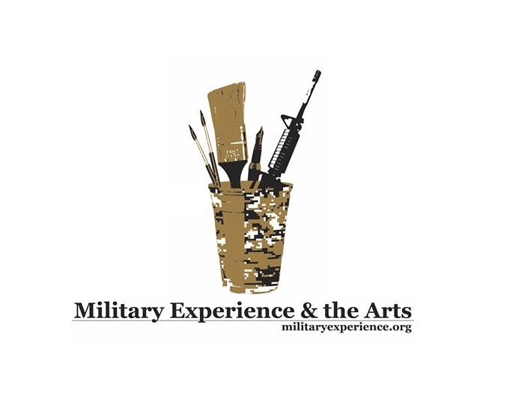

NEWS RELEASE
Media contact: Robin Brooks
Public Affairs
(760) 408-3762

Military Experience & the Arts: National Symposium Welcomes Oklahoma Veterans, Families and the General Public

LAWTON, OK (April 29, 2015) -- The Oklahoma Military Experience & the Arts National Symposium (MEA 2) is scheduled for Thursday, May 14 through Sunday, May 17 on the campus of Cameron University. The educational event, geared toward military veterans and families throughout the State of Oklahoma, as well as the general public seeking a better understanding of how veterans cope within the military environment, is a golden opportunity to allow artistic inclinations to blossom through more than 70 thought-provoking workshops. Topics related to writing, poetry, filmmaking, music, papermaking, performance art and stress reduction are among the symposium offerings. Veterans from Oklahoma, and surrounding states, are invited to register for the symposium – which includes support with lodging, meals, transportation, post-traumatic stress, and most significantly, a safe, open venue for social exchange among fellow veterans of every generation and branch of service. The Military Experience & the Arts (MEA), is a national 501(C) 3 non-profit organization dedicated to serving military veterans and the artistic experience primarily through honoring creative expression. The Lawton MEA symposium marks the second in the nation, the first being held at Eastern Kentucky University in 2012. Presenters include professional writers, published authors and poets; fine artists, photographers, actors, dance troupes, documentary filmmakers – and art therapists, who work closely with veterans, particularly utilizing the concept of art as a means to process the internal complexities of war and combat, including unusual aspects of serving in the military.

-More-
Keynote speaker, Benjamin Patton, who is a filmmaker, author, developmental psychologist and the youngest grandson of World War II’s infamous General George S. Patton Jr., will be on-hand educating veterans on the finer points of documentary filmmaking, in a format created to assist with processing traumatic, war-related experiences. “I grew up with a very strong sense of service, particularly with regard to military personnel and uniformed personnel,” Patton said. “We really need to make an effort to acknowledge the service of those who, as my dad used to say, ‘missed a meal or heard a shot fired in anger.’ We do what we can to give back to that community and make their lives as fulfilling and rich as possible. “My main focus right now is the work I’m doing for the Patton Veterans Project, which is to serve the military community, you might say, in a different way; by providing a therapeutic intervention involving filmmaking to help veterans cope with service-related stress . . . and their families,” Patton said. Patton will also share excerpts from his book, “Growing Up Patton: Heroes, History and Family Wisdom.” Theater actor and performance artist, Doug Berky, in a similar fashion to Patton, grew up on military bases for most of his life, as his father spent 20 years in the Air Force. Berky will take the stage at MEA Oklahoma utilizing universally-themed, ancient stories to address veterans and military families. “The ‘Tiger’s Whisker’ is an ancient story from Korea,” Berky said. “It’s about a woman’s journey whose husband comes home from war and her trying to find the silver bullet that will help him deal with the trauma he suffered in that experience.” Roman Baca, a former U.S. Marine who is also a dancer and choreographer, is a featured performer. Baca is the artistic director of Exit 12, a New York City based dance-company. Exit 12 is known internationally for communicating complex military issues and experiences to audiences through ballet movements and expression. Popular Oklahoma Flutist and Vietnam veteran Albert Gray Eagle is on the roster to perform music and teach authentic flute-making techniques throughout the entire symposium. “I hope if it is just one person I can reach and give hope to . . . I am blessed to allow that to go through,” Gray Eagle said. “If you can help someone, by all means, that is your duty as a human being.” Veterans can access additional information about the upcoming Oklahoma MEA symposium, and register for the event at www.militaryexperience.org. The symposium is open to veterans, military families, active duty service members, reservists, retirees and the general public. Registration is $20. Active duty military and spouses may register for free!
- More -
About MEA: Military Experience & the Arts (MEA) is a national 501(C) 3 non-profit organization dedicated to serving military veterans and the artistic experience primarily through honoring creative expression in writing, poetry, music and the performing and visual arts.

Media Inquiries:
Robin Brooks, Public Affairs Director, Military Experience & the Arts
(760) 408-3762
robinbrooksinfluentialpublicaffairs@nym.hush.com

Oklahoma Symposium Activities, General Schedule and Donations:
Jason Poudrier, Oklahoma Symposium Director, Military Experience & the Arts
(580) 284-1356
jpoudrie@cameron.edu

Military Experience & the Arts Headquarters:
Travis Martin, Founder
David Ervin, President
president@militaryexperience.org

Ben Patton - http://www.iwastherefilms.org/
Doug Berky -http://www.dougberkytheatre.com/
Exit 12 - http://exit12danceco.com/
Albert Gray Eagle - http://www.imaginativz.com

###

