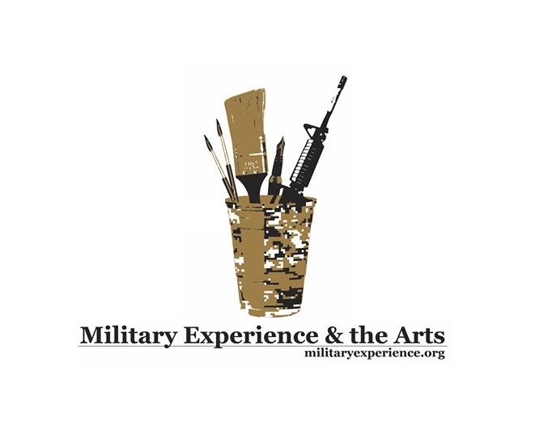

NEWS RELEASE
Media contact: Robin Brooks
Public Affairs
(760) 408-3762

ART-ifacts Veteran Art Exhibition Opening as Part of Oklahoma’s Military Experience & the Arts National Symposium

LAWTON, Okla. (May 7, 2015) – Along with poets, musicians, filmmakers and international performing artists, Oklahoma’s Military Experience & the Arts Symposium includes the opening of “Healing Threads: War, Trauma and Art,” a veteran-produced ART-ifacts exhibition, which is a project of the nationally acclaimed organization, Arts & the Military. The art exhibit kicks-off Thursday evening, May 14 at approximately 6 p.m. at the Lawton Veterans Center located at 1016 SW C Avenue, Suite B with an opportunity for viewing by the general public through May 29. Several pieces of the exhibit will be displayed at varying venues such as the Leslie Powell Foundation and Gallery in downtown Lawton and Cameron University, the official host of the MEA symposium. Tara Tappert, an art historian and curator from Washington, D.C., who recently completed a John W. Kluge Library of Congress fellowship related to research on World War I veterans and art therapy, is scheduled to address MEA attendees at the ART-ifacts opening reception and provide educational lectures at the MEA symposium, among numerous workshops on arts-related topics: “The purpose of both the ART-ifacts exhibition -- Healing Threads: War, Trauma, and Art -- and my two presentations -- ART FROM WAR: Documenting Devastation/Realizing Restoration and In Service to the Nation: Arts and Crafts and the Military -- is to demonstrate that creative expression as a response to war trauma has a long and honorable history. The exhibit features paper artwork produced at present day workshops hosted by Combat Paper Project, Peace Paper Project, Panty Pulping, and Button Field Paper,” said Tappert.
- More -
“Workshop participants -- veterans, military family members, civilians of war torn communities, and domestic violence survivors -- take military uniforms and other significant items of clothing worn during experiences of war and violence, and transform the uniforms and clothing into meaningful and poignant artwork,” Tappert said. “The lectures,” said Tappert, “explore the history of creative expression as a way to address war trauma. Within the military, beginning with the First World War, arts and crafts making was used as a form of rehabilitation, and beginning with the Second World War, arts and crafts making were promoted as recreational activities for soldier well-being and efficacy.” A preview of Ms. Tappert’s lecture can be found at http://www.c-span.org/video/?323952-1/discussion-world-war-veterans-art-therapy The Oklahoma Military Experience & the Arts National Symposium is scheduled for Thursday, May 14 through Sunday, May 17 on the campus of Cameron University. The educational event, geared toward military veterans and families throughout the State of Oklahoma, as well as the general public, is a golden opportunity to learn something new and allow artistic inclinations to blossom. Workshop topics related to writing, poetry, filmmaking, music, papermaking, performance art and stress reduction are among the symposium offerings. Veterans from Oklahoma, and surrounding states, are invited to register for the symposium at a cost of $20. Active duty service members and spouses may register free-of-charge. Additional information can be found at www.militaryexperience.org. To learn more about Arts and the Military: http://www.info@artsandmilitary.org
About MEA: Military Experience & the Arts (MEA) is a national 501(C) 3 non-profit organization dedicated to serving military veterans and the artistic experience primarily through honoring creative expression in writing, poetry, music and the performing and visual arts.

Media Inquiries:
Robin Brooks, Public Affairs Director, Military Experience & the Arts
(760) 408-3762
robinbrooksinfluentialpublicaffairs@nym.hush.com

Oklahoma Symposium Activities, General Schedule and Donations:
Jason Poudrier, Oklahoma Symposium Director, Military Experience & the Arts
(580) 284-1356
jpoudrie@cameron.edu

Military Experience & the Arts Headquarters:
Travis Martin, Founder
David Ervin, President
president@militaryexperience.org

###

